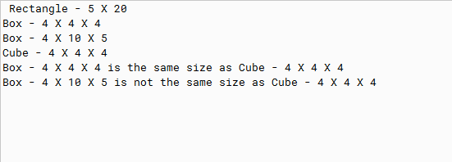

PMR: This code was easy to build since most of the main code was provided. I enjoyed this project. Its good review. Overall I’ve enjoyed module 13 a lot.

/\*

\* By Anika Jallipalli

\* Date: 2/3/2020

\*

\* PMR in README.txt

\*/

public class TestNew

{

public static void main(String[] args)

{

//create objects

Rectangle3 rectangle = new Rectangle3(5, 20);

Box3 box1 = new Box3(4, 4, 4);

Box3 box2 = new Box3(4, 10, 5);

Cube3 cube = new Cube3(4);

//print

showEffectBoth(rectangle);

showEffectBoth(box1);

showEffectBoth(box2);

showEffectBoth(cube);

//print comparisons

box1.equals(cube);

box2.equals(cube);

}

public static void showEffectBoth(Rectangle3 r)

{

System.out.println(r);

}

}